##### Printed Black Giftset

##### 

**Price: Rs.1200/-**

Black Pattern printed gift set: card + notebook. best for gifting and using.

Nothing beats fresh, new notecards and notebooks. Perfect for scribbling messages to loved ones or yourself, this set features our 20 boxed notecards and envelopes and a hardback lined notebook.

SET INCLUDES:

x1 hardback lined notebook and x1 box of 20 notecards & envelopes

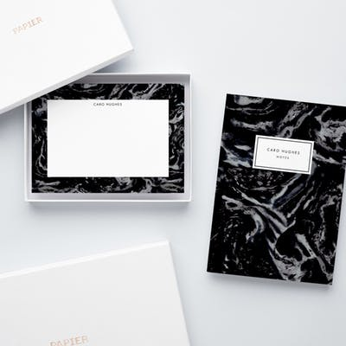

* Model Number: 20785856119
* Type: Gift set
* Promotional: No
* Style: Dotted
* Display Screen: show as the picture
* Use: Paper
* Origin: Japan
* Color: white ,blue, black.
* Size: 6.5cm x 12cm x1cm
* Type 1:  Dairy & card